How to Fork a repository as a student
Login to GitHub account
Access the GitHub repository shared by the instructor
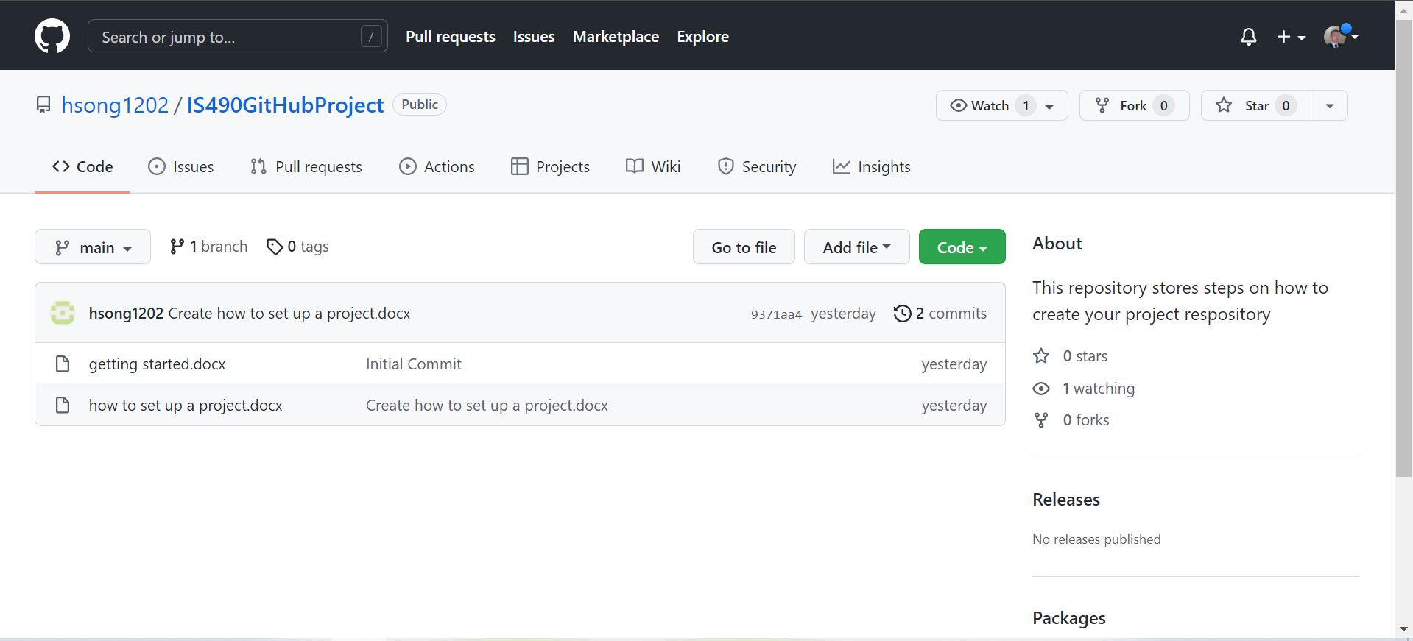
Click Fork in upper right corner of the screen below the notification icon
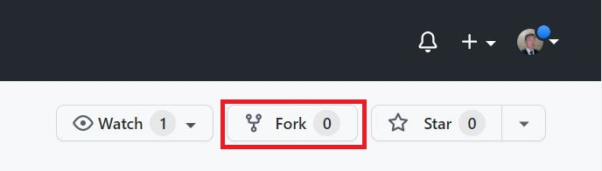
Following screen will appear
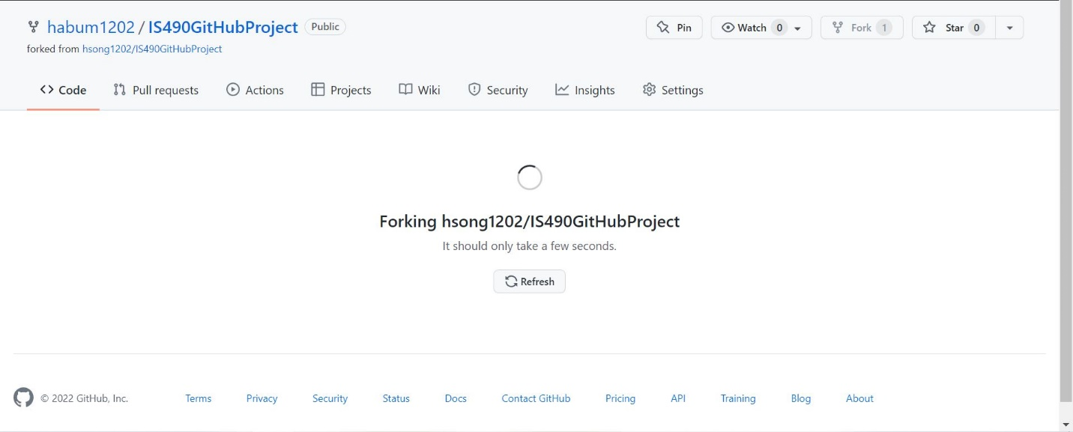
Return to your GitHub main page
Verify that the project repository has been added to the list of Repositories
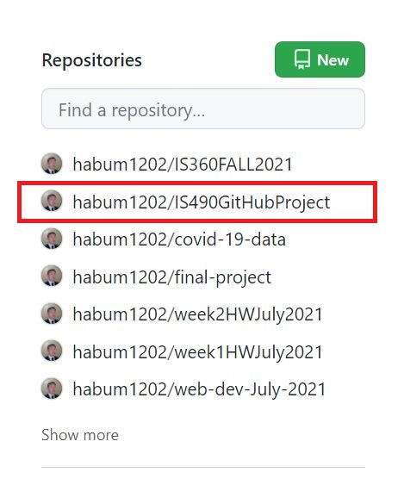
Clone repository to local drive

